
THE NATIONAL INSTITUTE OF ENGINEERING

MYSURU-570008

DEPARTMENT OF ELECTRONICS AND COMMUNICATION ENGINEERING

ANALOG & DIGITAL PROJECT [EC0439] –Vth Semester

Project Report On

ENCRYPTED DATA TRANSFER

USING RADIO FREQUENCY

Under the guidance of

Dr.Gnane Swarnadh Satapathi
Assistant Professor, Dept. of ECE

Smt.K.V.Nagalakshmi

Assistant Professor, Dept. of ECE

 | Submitted By:
Name: AKASH .V.DESHPANDE |  | USN: 4NI16EC006
Name: AKSHAY VISHWANATH |  | USN: 4NI16EC008
Name: AVINASH KUMAR |  | USN: 4NI15EC019

ACKNOWLEDGEMENT

We would like to take this opportunity to express out profound gratitude to all those people who are directly or indirectly involved in the completion of this project. We thank each and every one who encouraged us in every possible way.

We would like to thank our principal Dr. G. RAVI for letting us to be the part of this prestigious institution and letting me to explore abilities to the fullest.

We would also like to extend our sincere gratitude to Dr. Rohini Nagapadma, our H.O.D, for being the source of inspiration and instilling an enthusiastic spirit in us throughout the process of project making.

We would like to express our heartfelt gratitude towards our project guide Dr.Gnane Swarnadh Satapathi and Smt.K.V.Nagalakshmi for their kind guidance, valuable knowledge and experience.

We are thankful to our parents, family and friends for their constant support, inspiration and encouragement, for their helping hand.

1

INDEX

 |  | page number
1) | Abstract | 1
2) | Introduction | 2
3) | Encryption and Decryption | 2
4) | Block Diagram | 3-4
5) | Program | 5-6
6) | Result | 7
7) | Applications | 7

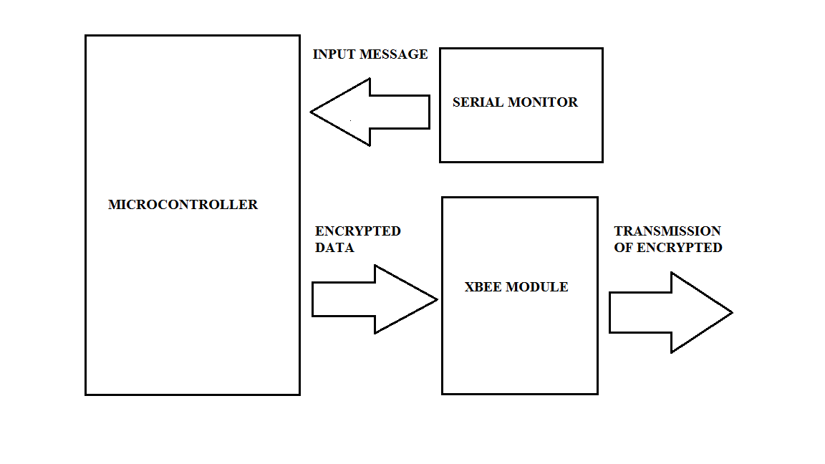
TRANSMITTER :

3

RECEIVER:

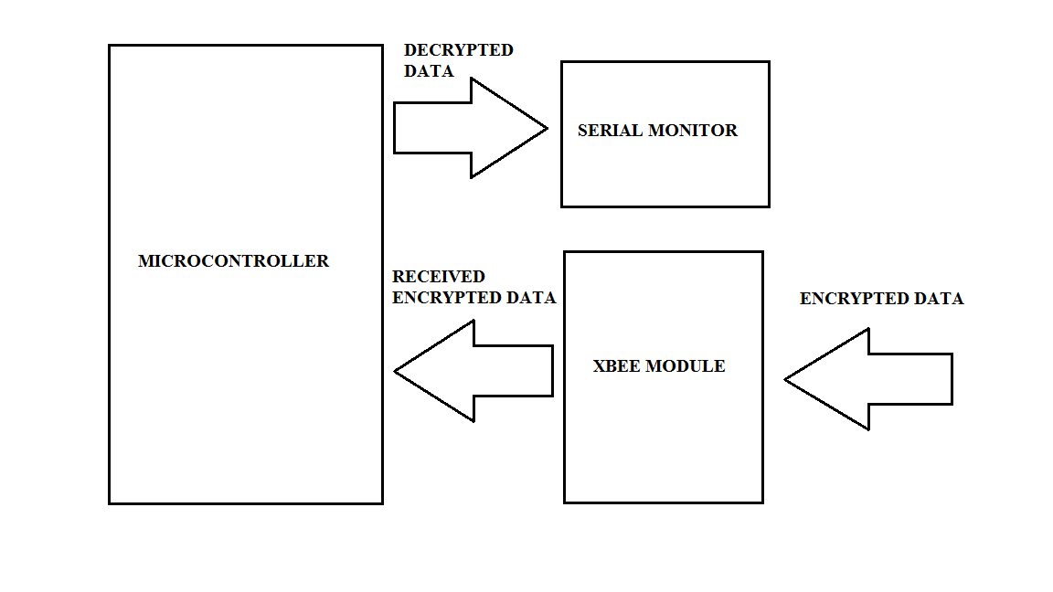

4

ABSTRACT:

We have discussed in project the secures wireless communication in detail. This process is very useful in modern applications of wireless communication. First of all, we entered the message from keyboard. This message is encrypted and then it is transmitted using radio frequency transmitter. The characters which are entered at the transmitter will also be displayed on the serial monitor for our convenience and so that we can enter our data in easier way. At the receiver when the encrypted message is received then this message is decrypted by the microcontroller and is displayed on the serial monitor .The mode of communication that we have used in our project is simplex data transmission over radio frequency.

1

INTRODUCTION:

This project is about the secure wireless communication over RF. The main advantage of this project is that the data cannot
be received until and unless you don’t have receiver code that is compatible to transmitter. At the transmitter, keyboard will be attached to microcontroller which is used to input the message. This message is encrypted and then it is transmitted using radio frequency transmitter. The data which will be entered at the transmitter will also be displayed on serial monitor for convenient entry. At the receiving end when the encrypted message is received then this message is decrypted by the microcontroller and is displayed on the serial monitor. The mode of communication that we have used in our project is radio frequency channel.

In our project we have used a schemes of data encryption and decryption. The Xbee modules that we have used for data transmission and reception works at 2.4GHz.

ENCRYPTION AND DECRYPTION:

Cryptography is a process in which we convert a plain text or clear text message to cipher text message which is based on an algorithm that both sender and receiver know, and in this way the cipher text message can be obtained to its original form. In this way, a message cannot be read by anyone but the authorized receiver. The process of converting a plain message to its cipher text form is called enciphering. Reversing this process is known as deciphering. Enciphering and deciphering are other names of encryption and decryption.

Encryption is performed using ASCII table. Each character is converted to its equivalent ASCII code and is added with a unique number, which depends on the position of character in the string. Then the summed number is again converted to its ASCII equivalent and is transmitted using XBEE module.

The data to be decrypted is received by the receiver and the reverse of encryption process takes
place, the microcontrollers are used to do the necessary function of encrypting the data and decrypting the same by programming them using proper code.

2

5

.

PROGRAM:

TRANSMITTER CODE:

#include<SoftwareSerial.h>

#include<string.h>

int tx=4,rx=3;

String str,en_str;

int d;

SoftwareSerial xbee=SoftwareSerial(rx,tx); //for serial communication

void setup()

{

Serial.begin(9600);

xbee.begin(9600);

Serial.println("Hi\nWelcome to the introduction of data transmittion...\n"); Serial.println("Enter the data to be encrypted and transmitted\n"); }

void loop()

{

while(Serial.available()>0)

{

str=Serial.readString();

d=str.length(); //length of string

en_str[0] = d;

for(int i=1;i<d;i++)

{

char a=str[i]+i; //encoding

Serial.print(str[i]);

Serial.print(" encoded ");

Serial.println(a);

en_str+=a; //new string

}

Serial.print("The original message is::: ");

Serial.println(str);

Serial.print("The encoded data is:::\n");

Serial.println(en_str);

xbee.print(en_str); //data transmitted

en_str=" ";

}

}

5

RECEIVER CODE:

#include<SoftwareSerial.h>
#include<string.h>
int tx=4,rx=3;
String de_str;
char str;
SoftwareSerial xbee=SoftwareSerial(rx,tx); //for serial communication

void setup()
{
Serial.begin(9600);
xbee.begin(9600);
Serial.println("Decryption of transmitted data\n");
Serial.println("starting the reciver\n");
}

void loop()
{
while(xbee.available()>0)
{
str=xbee.read();
Serial.println(str);

}
}

6

APPLICATION:

Electronic Money:
It includes transactions carried out electronically with a net transfer of funds from one party to another, which may be either debit or credit and can be either anonymous or identified. There are both hardware and software implementations.
Encryption is used in electronic money schemes to protect conventional transaction data like account numbers and transaction amounts, digital signatures can replace handwritten signatures or a credit-card authorizations, and public-key encryption can provide confidentiality.

MILLITARY APPLICATION:

It can be used to send a secret message from one base station to another station in such a way that even if third
party detect it in any manner will be unable to decrypt it and the message remains safe.

RESULT:

- Hi Welcome to the introduction of data transmission…
Enter the data to be encrypted and transmitted

The original message is::: BOMB IS AT BLOCK A
The encoded data is::: BPOF%OZ(I^+MX[OZoR

Decryption of transmitted data
Starting the receiver

BPOF%OZ(I^+MX[OZoR
BOMB IS AT BLOCK A

7

7

